Marilee Ohlhoff
13235232
Pre-Prac_2

Question 1
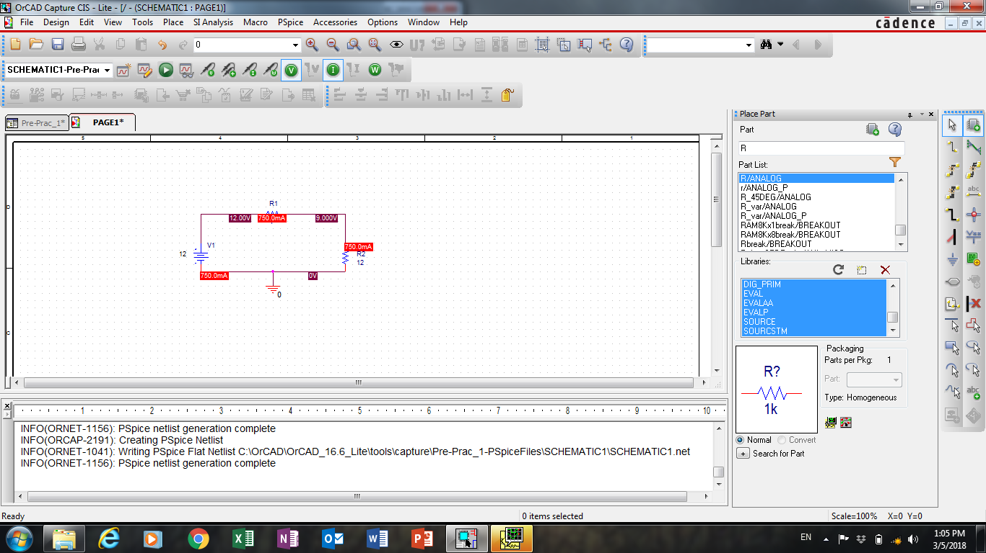

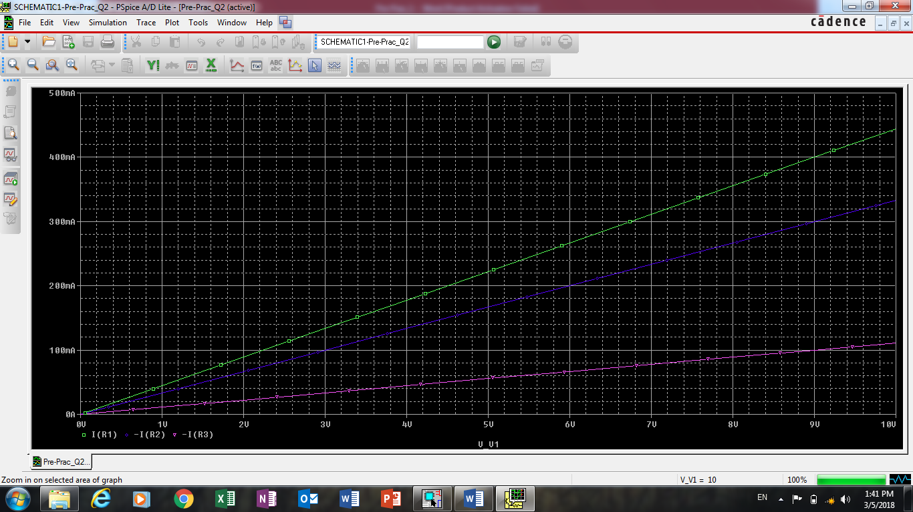
Question 2
(b) i.

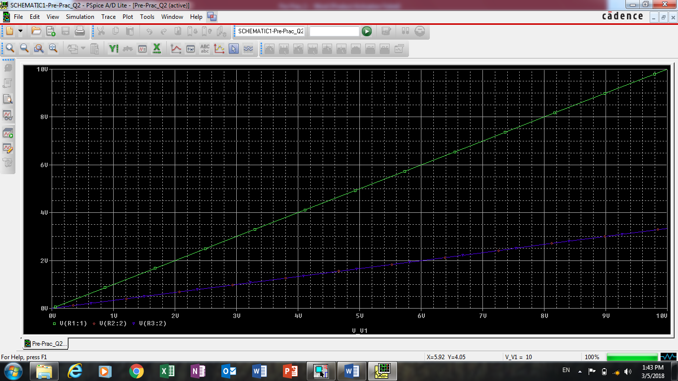
ii.

